**Data Analysis Project**

To maximize our efficacy, we should send out marketing emails on the most popular day of the month or popular day of the week. In this graph, I have provided the count of sales based on the day of the week.

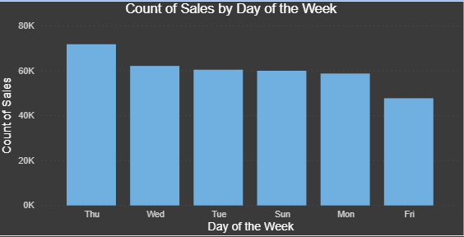

This graph shows that Thursday is the most popular day of the week to be sending out marketing emails. In the following graph, I have provided the count of sales based on the day of the month.

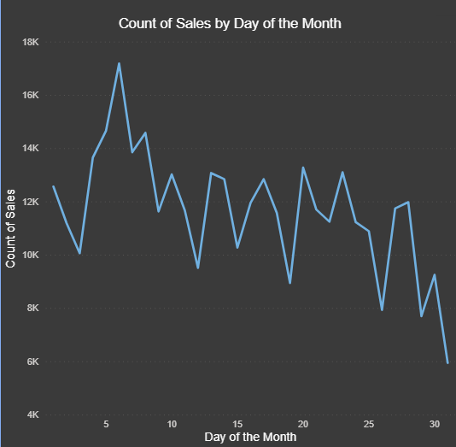

According to this graph, the 6th day of the month is the most popular day out of the month for sales.

Basing off the data that was given to me, it was manually placed into seven categories: Home Accessories/Decorations, Knitted/Felt Accessories, Children, Kitchen, Christmas, Fashion/Embellishments, and Party/Stationary.

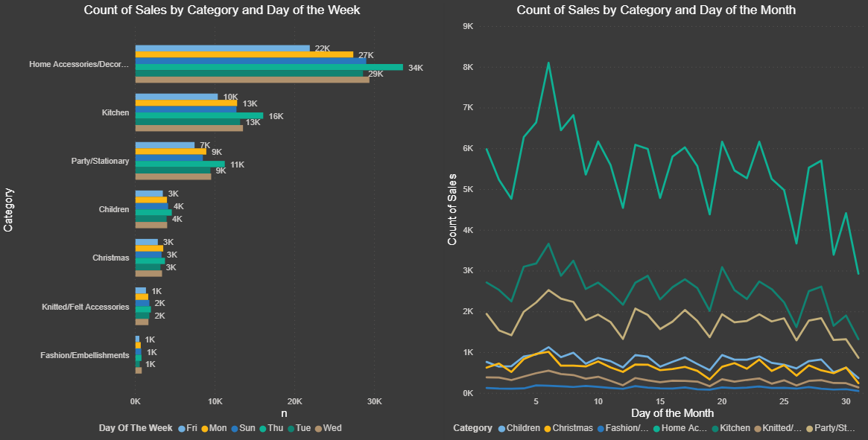

To go into further details, I have provided charts for the day of the week and day of the month based on category to see if there is a different day of the week or day of the month that would have more sales than the general charts. Based on these charts, all the categories also have their most sales on a Thursday and on the 6th of the month. Overall, I would highly suggest sending out marketing emails on a Thursday rather than on the 6th of the month because most company send out paychecks on a Friday so they have the time to plan on what they would like to purchase.

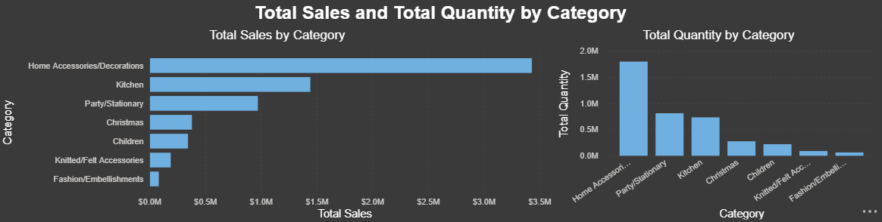

These charts provided the total sales and total quantity based on category in descending order to visualize what sold the best. Home Accessories/Decorations generated the most revenue and sold the most out of all categories.

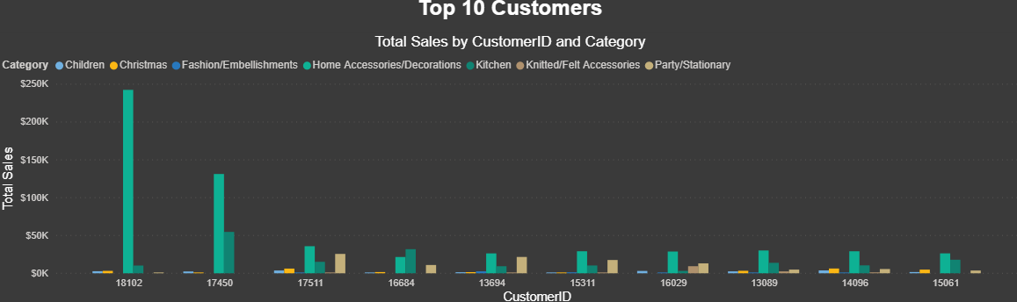

This chart shows us the top 10 customers based on total sales by category. These customers bought items from Home Accessories/Decorations more than any of the categories. To encourage our top customers to spend more, we should create a reward system for being our top customers. If these customers purchase from us at least 10 times, they should be able to unlock their reward system. If they spend $50 (or more) at once, reward them with $5 off, if they spend $75 (or more) at once, reward them with $10 off, and if they spend $100 (or more), reward them with $20 off. This will encourage our top customers to spend more money, so they are able to get the discount. This will also encourage other customers to get into the reward system. I suggest having a set amount discount rather than a percentage discount because we don’t have to make the customers think how much they are saving and do the extra work to calculate it.